**Freelancing**

**Hustler’s University**

* **SOP (Skills Offer Prospecting)** is the way we will learn the skills in this course
* **Skills:** you’ll be walked through picking a skill
* **Offer:** without an offer you have nothing that clients will pay you for so let’s get you an offer
* **Prospecting:** you’ll learn how to find clients for your offer
* We can use **Chat GPT** to pick a skill for freelancing

**Skills:**

* Check **“Part 1”** of questions/answers file
* Following link can potentially help you as a beginner freelancer: <https://drive.google.com/file/d/1QtHiRdz0Cd4LXqakjdM6ULiIhKyPc0Ij/view>

**Offer:**

* Provide a valid **argument** of why customers should consider you e.g., social proof e.g. I am going to make you a landing page and see what you can improve in your current landing page
* How you **facilitate** your skill matters
* Send DMs in different wordings with different types of people in different kinds of ways
* You can tag @captains in the chat and ask them questions
* Before you start charging, give some free services because you need **experience** and **experience breeds confidence**
* In start, don’t charge much until you have experience to do so
* **Important:** Don’t charge premium price at first

**Prospecting**:

* We are going to find people via social media specifically through Instagram and Twitter and leverage that through Facebook to find that are going to be a great fit for your service
* You have to pick a niche to narrow down it
* You are looking for somebody who:

1. Has good amount of following e.g., 10k-100k followers
2. Has good engagement e.g., 200-15k likes per post dependent on followers
3. They have something to sell because how are you going to help them make money if they don’t have anything to sell

* <https://gumroad.com/discover> can be used to sell your skills/services or to find clients
* Find client through **Gumroad:**
  + to find clients who has reach and engagement and something to sell, then, message them through Twitter and Instagram etc (apply money-back method)
  + E.g., if you find a fitness guy, you can offer him making a website, editing a video, helping with engagement, and tons more
* Find people through **Social Media:**
* **6 fig DM Script:**
  + Compliment them (something specific such as a recent thread they did)
  + Ask a question that sets for qualifying them for your service
  + Lead the convo to telling them you have ideas for them & that you can tell them move over the phone
* **DM styles examples:**
  + **DM style 1:** A specific compliment. Then end with a question (that sets them up for your service) Example for email copywriting offer: Hey Gabby, your recent thread about [specific compliment referencing a recent post] stuck out to me because [insert]. Are you currently repurposing your threads for your newsletter?
  + **DM style 2:**
    1. Custom line to catch their attention (DO NOT write something generic to “save time”).
    2. Problem or what you’ve done for other people (social proof)
    3. Give some BENEFITS (how you will help them specifically) of how you’d help, not features (I’ll write 3 emails a week blah blah).
    4. CTA leading them to a call in this style you’re pitching the service with a call to action at the end… so they get on a call for you to see if they’re a good fit to work with.
  + **DM style 3:** For prospects you have built rapport with, you want to make a strong impression and you LOOK trustworthy/speak the language of the person you’re reaching out to…. Create a short video explaining how you came across the prospects profile, how you can help them, and offer to get on a call with them to explain in more detail the ideas you have to help them. Yes, this could be a bit more energy/effort so do this when you think they’re a strong prospect.
  + **DM style 4:** Hey, xyz [specific compliment] Say you’re new to what you’re doing but confident you do great work. Then offer to work with them in exchange for a testimonial. You’ll need to work with them for a bit of time, not just ONE VIDEO or something super tiny. You need to demonstrate REAL VALUE for them, aka overdeliver so that they can vouch for your work. You then use this testimonial in your social media posts, story, reels, twitter threads, in DMs to new prospects, on your website, on your link tree, etc.
  + **DM style 5:** This style works when you have GREAT social proof, a well-built profile, lots of followers, etc. on your account…. Be casual. Hey, xyz your post about xyz caught my eye because xyz. That reminds me of a previous client where I helped them go from [insert figure like $4k to $50k] per month. Your persona makes me think I can help you do the same. I’m headed to the gym now [or insert other activity], but I’m free early tomorrow to jump on a call to discuss this more. Just let me know! attach proof of your claim
  + **DM style 6:** ONE LINE QUESTION. You noticed something about their profile or liked something they said? Ask a question. It will open them to a reply - it’s SHORT so they aren’t having to read your paragraph DM Then set them up for your pitch/offer/call etc. Remember: You don’t have to pitch them your whole service in the first DM. You do have to make this about them, though.
  + **DM style 7:** This method is for those who are experienced with their skill... It’s also best for prospects who you have built rapport with and you’d really like to worth with them. You will choose one of the other DM styles (ideally keeping it brief) Then create a LOOM video recording of you critiquing something of theirs. Example: A Loom recording of you commenting on their IG profile (if you manage IG pages) and letting them know what you would do differently. Or for someone that has a website, a recording of you commenting on their site. This should only be 2-3 minutes long.
  + If they don’t respond, follow-up with a short message 2-3 days later. You can also use another platform e.g. IG and let them know that you messaged on twitter about xyz
  + Make sure spellings are correct. USE YOUR BRAIN
* **Short brief on DMs (IMPORTANT):**

1. REWRITE and READ over your DM again. You DO NOT want to send out a “rough draft.” You should read over your message multiple times before sending it out.
2. Then send out your DM in batches of 10 per day (10 per social media platform to avoid problems)
3. Once you have sent your DM 20 times (this should take you 2 days) then…
4. Keep testing your DM and change it based off of the responses
5. Come back to get more feedback if you feel you need it
6. You’ll keep sending DMs until you have your desired number of clients If you did choose to have them get schedule a call with you

* Use this script with some twist (since so many people are using exact same script) and message people, if they are interested, then, talk on call or messaging for further discussion
  + And if they are not interested, then, ask them the follow-up question e.g., “do you happen to know anybody who is interested in my services?”
* Check **“Part 2”** of questions/answers file
* Go to the following of the person of your interest because they might follow someone of their interest
* Freelancing is **anti-thinking**

**Making your first 100$:**

* People don’t get out of their brokieville because of their beliefs
* **Flipping:** is the simple skill of finding items for free or cheap and then selling them for a profit. The reason I like this skill so much for brokies (I used to be one) is because you don't need much if any money to get started
* Your flipping business revolves around the items that you sell. YOU make money when you sell items for a profit
* Best items to sell
  1. Wood furniture
  2. Leather furniture
  3. Garden furniture
  4. Ornaments
  5. Electronic garden tools
  6. Power tools
  7. Household appliances
  8. Sports equipment
  9. Vintage sportswear
  10. Designer clothes and shoes
  11. Bikes
  12. Electronics
* Craigslist, Facebook, marketplace, and OfferUp are some platforms for selling stuff
* 3-step process to sell things
  1. Get it
  2. List it
  3. Profit
* Things that attracts customers to your photos:
  1. **Headlines:**
* Use good headlines, good pictures for your product e.g.,
  + Bad Headline – Good Quality Brown Couch for Sale
  + Great Headline – Beautiful Leather Couch in (Great Shape)
* **Remember, you want to stand out and catch their eyes**
  1. **Photos:**
* What makes great photos:
  + Good lighting (no dimly lit photos)
  + Good background
  + Take 2-3 photos from different angles
  + Bad photo example:

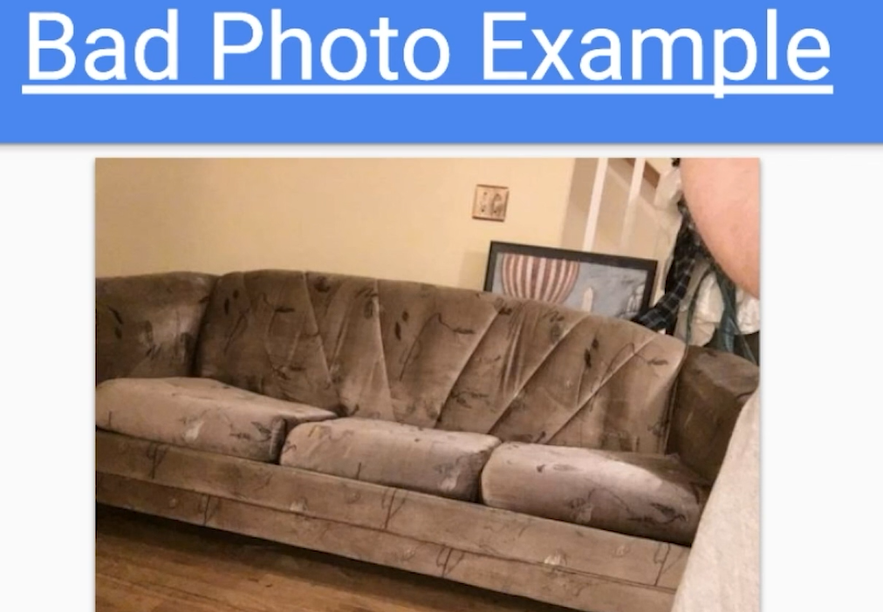

* + - Good Photo Example:

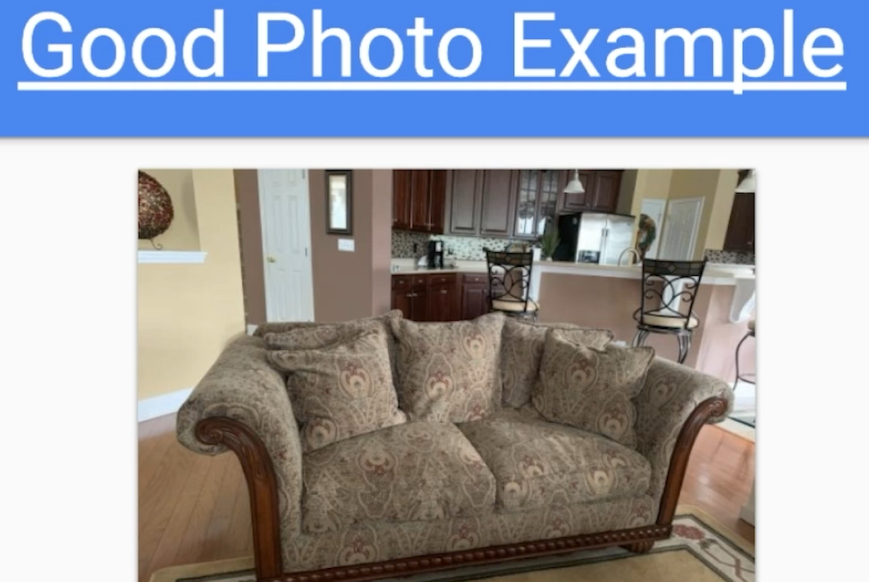

* 1. **Description:**
     + Clear and concise description is written like this:
       - Brief description (what your item is/the condition)
       - Accepted method of payment
       - Contact info (Always allow for them to call/text/email you)
* Accepted Payments:
  1. Cash
  2. Venmo
  3. Stripe
  4. Online
  5. **NO** checks
* With *furniture*, it’s less items and more profit
* Examples of items e.g.,
  + Furniture: Couches, Recliners, Dressers, Bookshelves
  + Appliances: Specialty blenders (such as the Ninja), washers, dryers, grills, and fridges
  + Electronics: Printers, routers, jailbroken cell phones
* Two methods to find items which you can sell & profit from:
  1. Finding free items to list
  2. Buying items for a discount and selling for a profit
  + To get the most money you will be leveraging both
* Hire a team to help you out as you start earning more money
* Join Facebook groups to help you buy and sell
* Post your stuff in as many groups as possible and do it on as many platforms as possible as this increases the likelihood of getting your stuff purchased